SIENA COLLEGE
FIFTEENTH ANNUAL
HIGH SCHOOL PROGRAMMING CONTEST
MAY 15, 2000

PROBLEM # 7 ONLY THE SHADOW KNOWS?

Background Information: A very famous 20th century mathematician, Paul Erds, along with one of his pals conjectured that for every integer N greater than 4 there is a positive integer solution to the following expression.
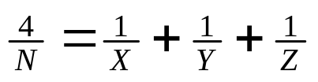

Programming Problem:

INPUT – Input from the keyboard a positive integer N greater than 4.

OUTPUT – Output to the screen an X, Y, Z triple that is an integer solution to the Erds expression for input value N.

EXAMPLES
Input: 5
Output: 2 5 10

Input: 6
Output: 3 6 6

